I decided it was time to bring back Vault Web View. The concept is pretty simple. Stick a tab with a web control in it. The web page shown is based on the selected object.
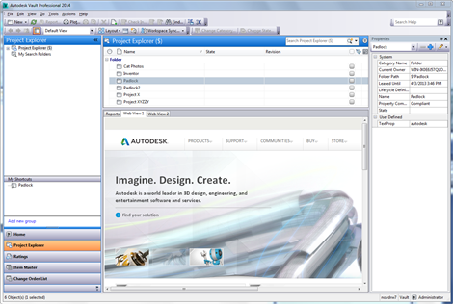
(click image for full view)
New for Vault 2014. You can now have multiple tabs. And you can determine which tabs show up on which entity types. Lastly you can use any Vault property or properties to determine the URL.
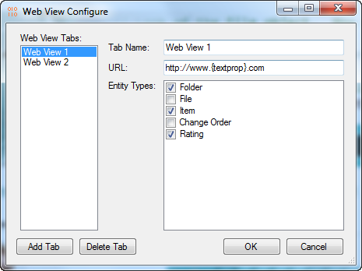
How it works is the admin sets up the URL for the tab. Anything in { } gets replaces by the property value in the selected object. So you can build up URLs based on Vault properties.
So, if a tab is set to “http://www.{sitename}.com” and you select an object where the sitename property is autodesk, you will see http://www.autodesk.com in the tab view.

Requirements:
Vault Basic/Workgroup/Professional 2014
Click here to download the application
Click here to download the source code
Click here for the 2012 version (sorry no 2013 version)

Notes:
- The resulting URL value must start with "http://". Otherwise you won't see anything in the tab view.
- If an object is in a folder, the folder properties can also be used in the URL. How it works is the selected object properties are applied to the URL. Next the parent folder properties are applied to the URL. This way if a property is not set in the selected object, the folder can provide the value.
- If there are empty property values that are required by the URL, then nothing will show up in the tab view.
As with all the samples on this site, the legal disclaimer applies.

